Exercise 1: Mocking and Stubbing
Scenario: You need to test a service that depends on an external API. Use Mockito to mock the external API and stub its methods.
Steps:
1. Create a mock object for the external API.
2. Stub the methods to return predefined values.
3. Write a test case that uses the mock object.
Implementation:
Pom.xml
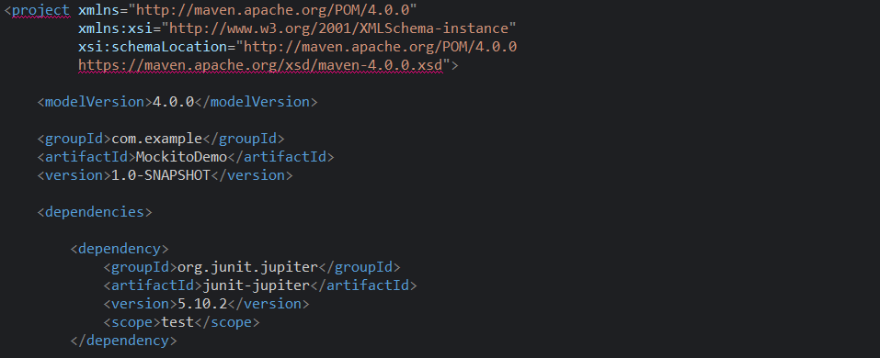
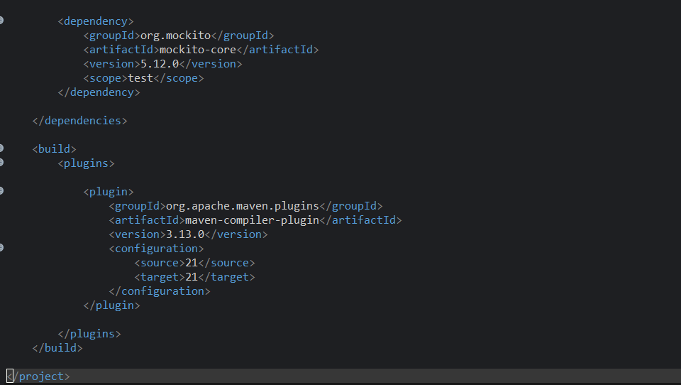
ExternalApi.java
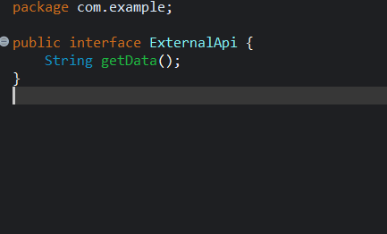

MyService.java
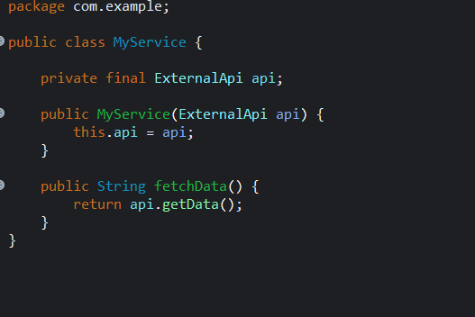

MyServiceTest.java
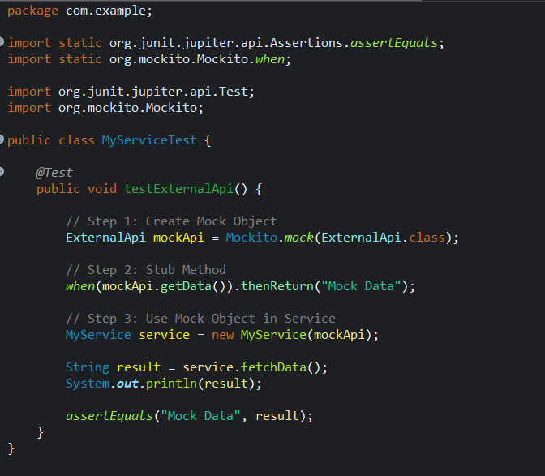

OUTPUT:
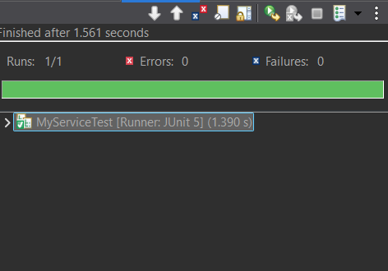
CONSOLE:
